Development Application

Determination

Policy

2025

**INFORMATION ABOUT THIS DOCUMENT**

|  |  |
| --- | --- |
| **Document Record Number** |  |
| **Document Owner** | Director Infrastructure and Environmental Services |
| **Document Development Officer** | Manager Planning and Regulation |
| **Review Timeframe** | Four (4) Years |
| **Last Review Date** | December 2025 |
| **Next Review Date** | December 2029 |

|  |  |  |
| --- | --- | --- |
| **Document History** | | |
| **Doc No.** | **Date Amended** | **Details/Comments** |
| **Version 1** |  |  |
| **Version 2** |  |  |
|  |  |  |

|  |  |
| --- | --- |
| **Further Document Information and Relationships** | |
| **Related Legislation\*** |  |
| **Related Policies** |  |
| **Related Documents** |  |

*\*Note: Any reference to Legislation will be updated in the Policy as required. See website* [*http://www.legislation.nsw.gov.au/*](http://www.legislation.nsw.gov.au/) *for current Acts, Regulations and Environmental Planning Instruments.*

**Contents**

1. Purpose 4

2. Background 4

3. Aim Of Policy 4

4. Legislation 4

5. Determination of Development Applications 5

6. Responsible Officer 7

# **Purpose**

The purpose of the policy is for Council to set its expectations on what development applications it wishes to determine and the type of applications it expects will be determined under delegated authority.

.

# **Background**

The Liverpool Plains Local Environmental Plan 2011 (LEP) sets out the land uses within each zone that are permissible with development consent. Clause 1.6 of this LEP nominates Council as the consent authority.

Council is the determining authority for most development applications that are lodged within the Liverpool Plains Shire. The exception are those applications that have some state significance, for which a planning panel has been appointed as the determining authority.

Most proposed local developments are of a routine nature and are generally consistent with the planning framework and community expectations. These applications are generally determined on Council’s behalf by staff utilising delegated authority.

Proposed local developments that are inconsistent with the planning framework or good planning, or have a wider social impact are generally referred to Council directly for its consideration and determination.

# **Aim of Policy**

The aim of this policy is to provide an overview of the types of development applications that Council considers that it needs to directly determine for any number of reasons, including the type of developments:

* That will generate strong public interest
* Is a high value application and will likely have significant social & economic impacts.
* Proposes a significant departure from Council’s Development Control Plan and/or that will have a measurable impact on the adjoining properties and the local amenity.

# **Legislation**

Clause 1.6 of this LEP nominates Council as the consent authority.

Where Council is the consent authority it must determine applications either:

* By a vote of Councillors at a formal Council meeting, or
* Under delegated authority given by Council or the General Manager to the determining officer.

# **Determination of Development Applications**

**DEVELOPMENTS TO BE GENERALLY APPROVED UNDER DELEGATION**

**No Notification**

The following types of development require no notification under the adopted Community Engagement Strategy & Community Participation Plan.



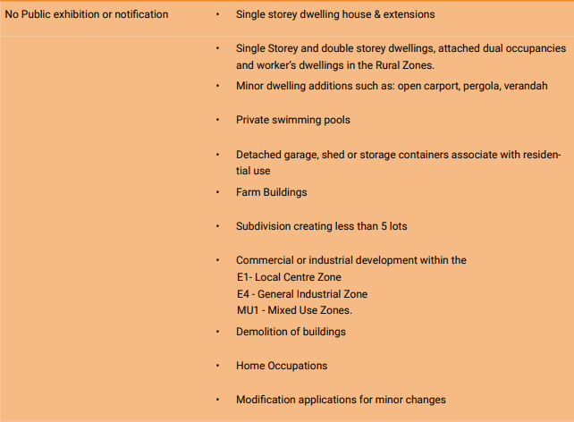

The above developments will generally be approved under delegated authority unless:

1. There is a significant departure for requirements of the Liverpool Plains Development Control Plan (DCP) including:
   1. Location of structures closer than 3 metres to the front boundary in the R1 General Residential and RU5 Village Zones except open carports, cabana & garden features.
   2. Any encroachment of the building line for Rural zones or R5 – Large Lot Residential Zone.
   3. Any enlargement of outbuildings that are 50% larger than the maximum size permitted in the DCP.

**Adjoining Owner Notification**

The following types of development require 14 days notification to adjoining landowners under the adopted Community Engagement Strategy & Community Participation Plan.



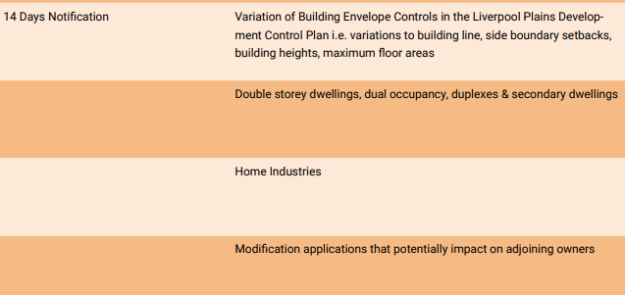

The above developments will generally be approved under delegated authority unless:

1. Significant departure for requirements of the Development Control Plan including:
   1. Location of structures closer than 3 metres to the front boundary in the R1 General Residential and RU5 Village Zones
   2. Any encroachment of the building line for Rural zones or R5 – Large Lot Residential Zone.
   3. Any enlargement of outbuildings up to a 50% increase to the maximum size permitted in the DCP.
   4. There are lesser departures that in the opinion of the Manager Planning & Regulation will cause an adverse impact on the adjoining properties and/or the amenity of the vicinity.
2. More than 3 objections are submitted, or
3. Submissions raise issues considered to have planning merit by the Manager Planning & Regulation.

**DEVELOPMENTS TO GENERALLY BE REFERRED TO COUNCIL FOR DETERMINATION**

**Adjoining Neighbour notifications & Advertising**

The following types of development require a minimum of 14 days notification to adjoining landowners plus advertising under the adopted Community Engagement Strategy & Community Participation Plan.



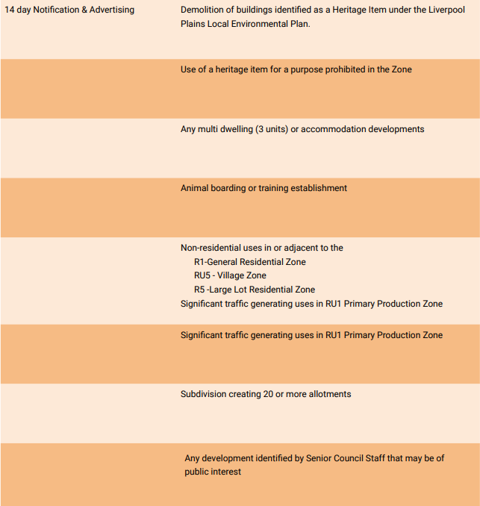

The above developments will generally be referred to Council for determination except:

* For Residential buildings that comply with the Council’s DCP
* Non-residential developments adjacent to the R1, RU5 and R5 zones that comply with Council’s DCP.
* where the developments are of a minor or incidental nature.

**Council Related Developments**

For the purposes of section 2.22 of the *EPA Act*, clause 9B (1) of Schedule 1 will specify that the minimum public exhibition period for a council-related development application is 28 days.

It is proposed that all development applications for Council related developments where Council is the determining authority will only be determined under delegated authority where it involves incidental work to existing Council buildings or grounds.

Otherwise, for Council related developments where Council is the determining authority, the applications will be referred to Council for determination.

**OTHER MATTERS TO BE REFERRED TO COUNCIL FOR DETERMINATION.**

The following proposals will be referred to Council for determination.

* Designated Developments
* Major rural, commercial, industrial developments with a value of over $2.0M.

# **Responsible Officer**

The Manager Planning & Regulation is the responsible officer for this procedure in conjunction with the Director of Infrastructure & Environmental Services.