Audit, Risk and Improvement Committee

External Independent Member

Information Pack and

Expression of Interest Form

2022

Contents

1. ABOUT LIVERPOOL PLAINS SHIRE COUNCIL 3

2. BACKGROUND 4

3. ROLE OF THE COMMITTEE 4

4. DUTIES OF MEMBERS 4

5. COMMITTEE MEETINGS 5

6. TENURE 5

7. REMUNERATION 5

8. SELECTION CRITERIA 6

9. EOI SUBMISSION 6

ANNEXURE 1 – EXPRESSION OF INTEREST FORM 7

# 

# 1. ABOUT LIVERPOOL PLAINS SHIRE COUNCIL

Centrally located in north-west NSW and strategically nestled in the foothills of the Great Dividing Range, Liverpool Plains Shire Council is a Local Government organisation responsible for maintaining extensive public infrastructure and delivering a wide range of services to a permanent resident population of approximately 7,800 residents across a region spanning just over 5,000 square kilometres.

Council is classified by the Office of Local Government as a Group 10 Large Rural council and sits within the New England North West State Planning Region. Council is an active member of the Namoi Unlimited, along with the Gunnedah, Gwydir, Tamworth and Walcha councils.

Council’s governing body comprises seven Councillors, one of whom is elected by the Councillors to serve as Mayor. Ordinary meetings of the Council are held each month, with extraordinary meetings held as required.

Council’s Executive Management Team (EMT) comprises the following structure:

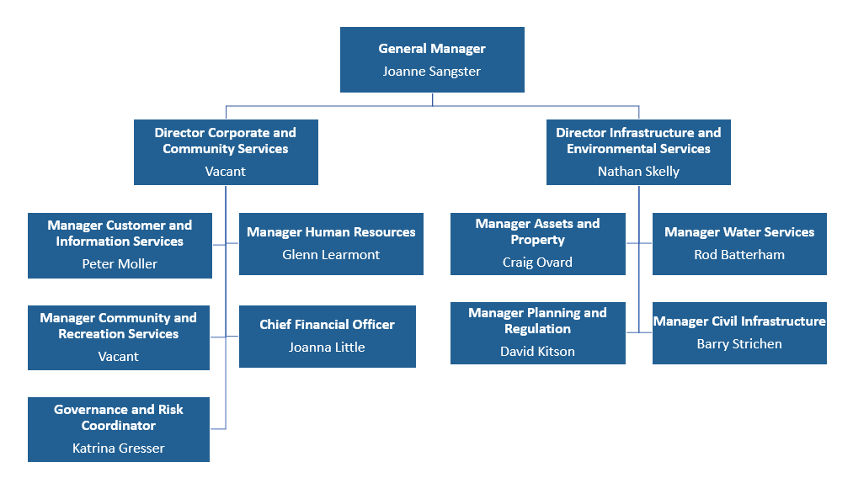

Further information about Council, including its Integrated Planning and Reporting framework documentation, is available from Council’s website at [www.liverpoolplains.nsw.gov.au](http://www.liverpoolplains.nsw.gov.au).

# 2. BACKGROUND

Council is committed to providing strong, efficient and effective Local Government to the Liverpool Plains Shire and providing open and transparent governance that meets community expectations. To enhance its governance framework, Council has established an Audit, Risk and Improvement Committee (the Committee).

While the Committee has operated since 2017, Council reviewed and adopted its Audit, Risk and Improvement Charter in 2020. The Committee comprises of two Councillors and three independent external members, one of whom is appointed to chair the Committee.

Through this Expression of Interest (EOI) process, Council is inviting applications from suitably skilled and qualified persons for an external member position to fulfil a vacancy. Members will be appointed for a period up to 1 September 2023, and this period may be eligible for extension beyond the initial term.

# 3. ROLE OF THE COMMITTEE

The Committee is an advisory committee that provides independent assurance, oversight and assistance to Council. Specifically, the Committee is to keep under review the following aspects of Council’s operations:

* Compliance
* Risk management
* Fraud control
* Financial management
* Governance
* Implementation of the Integrated Planning and Reporting framework
* Service reviews
* Collection of performance management data by Council and,
* Any other matters prescribed by the *Local Government (General) Regulation 2021*.

Further information on the role of the Committee and scope of its responsibilities is detailed in the Committee Charter.

# 4. DUTIES OF MEMBERS

Committee members are expected to:

* Maintain a current understanding of the legislation and regulatory requirements appropriate to the NSW Local Government sector
* Prepare for meetings, read all documentation distributed for discussion, and attend and actively participate in meetings
* Work cooperatively with Committee members and Council staff in achieving the objectives of the Committee
* Provide advice and recommendations to Council and/or the General Manager on items presented to the Committee and,
* Declare and manage any conflicts of interest they may have in matters being considered by the Committee, in accordance with Council’s Code of Conduct.

Council shall appoint one of the three independent external members as Chairperson, and one as Deputy Chairperson. The Chairperson has the following additional responsibilities:

* Chairing Committee meetings in accordance with Council’s Code of Meeting Practice and the OLG *Internal Audit Guidelines*
* Determining the dates of Committee meetings
* Guiding the development of the Committee’s meeting plan
* Approving business papers and minutes of the Committee and,
* Reviewing, in consultation with the General Manager, the performance of the Committee every two years.

The Chairperson may request regular briefings from Council’s General Manager and Director Corporate and Community Services on matters relating to audit, risk and improvement and is authorised to meet privately with the Independent Auditor and External Auditor at any time.

# 5. COMMITTEE MEETINGS

The Committee meets four (4) times each year, usually on the second Friday in February, May, August and November. Additional meetings of the Committee may be held, if and as required.

Meetings are held at Council’s Administration and Customer Service Centre at 60 Station Street; however, the Committee Charter allows for members to attend meetings in person or participate via telephone or web conferencing.

Council’s General Manager and Director Community and Corporate Services attend Committee meetings as observers, as does the External Auditor. The Committee may also invite other Council employees and contractors, external experts and Councillors to attend Committee meetings as observers and provide information, if and as required.

# 6. TENURE

Independent external members are appointed by Council resolution and may be removed by Council resolution.

# 7. REMUNERATION

The three independent external members of the Committee are remunerated on a per meeting basis for participating on the Committee at the remuneration level adopted by Council. The current remuneration rate is **$1,000 (plus GST) per meeting**, inclusive of any costs incurred in meeting preparation and attendance.

Any requests from Council for an independent external member to attend other meetings or conferences, such as the Local Government Internal Audit Forum, shall be remunerated separately as determined by the General Manager on a case-by-case basis.

# 8. SELECTION CRITERIA

The following selection criteria will be used in assessing applications:

1. Relevant professional qualifications
2. Relevant professional knowledge and expertise
3. Understanding of/ experience in Local Government
4. Understanding of the role of corporate governance in organisations and,
5. Current/prior experience on similar committees.

The independent external member shall possess demonstrated expertise in audit, risk and improvement. Accordingly, the EOI will be assessed with the aim of achieving an overall mix of skills and experience on the Committee.

# 9. EOI SUBMISSION

Council invites suitably qualified, independent individuals to submit an EOI to Council by **5.00pm on Friday 17 June 2022.**

Completed EOIs must include:

* Completed EOI Form (**Annexure 1**)
* A Curriculum Vitae and
* Certified copies of any qualifications held.

All enquiries or requests for information should be directed to Council’s Governance and Risk Coordinator, Ms Katrina Gresser on (02) 6746 1755 or via email at [council@liverpoolplains.nsw.gov.au](mailto:council@liverpoolplains.nsw.gov.au)

EOIs should be addressed to the General Manager and submitted electronically via email to [council@liverpoolplains.nsw.gov.au](mailto:council@liverpoolplains.nsw.gov.au)

# ANNEXURE 1 – EXPRESSION OF INTEREST FORM

|  |  |  |  |  |
| --- | --- | --- | --- | --- |
| **Applicant Details** | | | | |
| **Title:** | ☐ **Mr** | ☐ **Ms** | ☐ **Dr** | ☐ **Other:** |
| **First Name:** |  | | | |
| **Surname:** |  | | | |
| **Address:** |  | | | |
| **Suburb/Town:** |  | | **State:** |  |
| **Country:** |  | | **Postcode:** |  |
| **Phone Details:** | **Mobile:** |  | | |
| **Home:** |  | | |
| **Work:** |  | | |
| **Email Address:** |  | | | |

| **Declarations** | | | |
| --- | --- | --- | --- |
| Have you been employed in a senior management role, or in a position that can exert direct and significant influence over the subject matter of the Audit, Risk and Improvement Committee, at Liverpool Plains Shire Council within the last three years? | | ☐ Yes | ☐ No |
| Have you performed any services, including advisory roles, for Liverpool Plains Shire Council, which directly affect the subject matter of the Audit, Risk and Improvement Committee within the last three years? | | ☐ Yes | ☐ No |
| Have you acted as an advocate of a material interest on behalf of Liverpool Plains Shire Council or have you been engaged in litigation or in resolving disputes between Liverpool Plains Shire Council and third parties? | | ☐ Yes | ☐ No |
| Have you an immediate or close family member who is employed in a senior management role at Liverpool Plains Shire Council, or in any other position that can exert direct and significant influence over the subject matter of the Audit, Risk and Improvement Committee? | | ☐ Yes | ☐ No |
| If you answered “yes” to any of the above questions, please provide details of such relationship/s and/or conflict/s: | | | |
|  | | | |
| 1. Are you aware of any other real, potential or perceived conflicts of interest that could result from your appointment to this Audit, Risk and Improvement Committee? If yes, please provide details. | | | |
| ☐ **No** | ☐ **Yes** – details below: | | |
|  | | | |
|  | | | |
| 1. Have you been charged with, or convicted of, any criminal offences? Are you currently the subject of any ongoing criminal investigations? If yes, please provide details. | | | |
| ☐ **No** | ☐ **Yes** – details below: | | |
|  | | | |
|  | | | |
| 1. Have you been declared bankrupt or are you currently undergoing any bankruptcy or insolvency proceedings? Have you entered into a personal insolvency agreement? If yes, please provide details. | | | |
| ☐ **No** | ☐ **Yes** – details below: | | |
|  | | | |
|  | | | |
| 1. Have you been the subject of adverse findings by the Australian Securities and Investment Commission, The Institute of Internal Auditors, The Institute of Chartered Accountants, or any other professional standards body? If yes, please provide details. | | | |
| ☐ **No** | ☐ **Yes** – details below: | | |
|  | | | |
| 1. Have you you been the subject of adverse findings by the Independent Commission against Corruption or any other State or Federal anti-corruption body? If yes, please provide details. | | | |
| ☐ **No** | ☐ **Yes** – details below: | | |
|  | | | |

|  |
| --- |
| **Responses to Selection Criteria** |
| 1. Relevant professional qualifications. |
|  |
|  |
| 1. Relevant professional knowledge and expertise: 2. Audit, including financial and performance audit; and/or 3. Risk; including risk management, governance and control frameworks, legislative compliance, and fraud and corruption control; and/or 4. Improvement, including strategic planning, corporate performance, workforce planning and systems improvement. |
|  |
|  |
| 1. Understanding of/ experience in Local Government. |
|  |
| 1. Understanding of the role of corporate governance in organisations. |
|  |
|  |
| 1. Current/prior experience on similar committees. |
|  |

|  |  |
| --- | --- |
| **Other relevant information** | |
| Should you wish to provide further information that you feel may be relevant to Council’s consideration of your interest, please submit this as supporting documentation to your EOI. | |
| **Please indicate if you would like to be considered for the position of Chairperson/Deputy Chairperson?** | |
| The role and responsibilities of the Chairperson and Deputy Chairperson are detailed in the Committee Charter. | |
| ☐ | **Yes** – Consider me for the position of Chairperson/Deputy Chairperson. |
| ☐ | **No** – Do not consider me for the position of Chairperson/Deputy Chairperson. |

|  |  |  |  |  |
| --- | --- | --- | --- | --- |
| **Skills Matrix** | | | | |
| In the table below, please indicate how you self-assess your levels of skills and experience against each key responsibility of the Committee. | | | | |
| **Skills/Experience** | **Nil** | **Some** | **Sound** | **Expert** |
| **Audit** | | | | |
| Internal audit | ☐ | ☐ | ☐ | ☐ |
| External audit | ☐ | ☐ | ☐ | ☐ |
| **Risk** | | | | |
| Risk management frameworks | ☐ | ☐ | ☐ | ☐ |
| Insurance | ☐ | ☐ | ☐ | ☐ |
| Governance frameworks | ☐ | ☐ | ☐ | ☐ |
| Legal and compliance | ☐ | ☐ | ☐ | ☐ |
| Local Government legislation | ☐ | ☐ | ☐ | ☐ |
| Fraud and corruption control | ☐ | ☐ | ☐ | ☐ |
| Project/ contractor management | ☐ | ☐ | ☐ | ☐ |
| **Improvement** | | | | |
| Service delivery and reviews | ☐ | ☐ | ☐ | ☐ |
| Strategic/corporate planning | ☐ | ☐ | ☐ | ☐ |
| Performance data and measurement | ☐ | ☐ | ☐ | ☐ |
| HR/ workforce planning | ☐ | ☐ | ☐ | ☐ |
| Asset management planning | ☐ | ☐ | ☐ | ☐ |
| Information Technology (IT) | ☐ | ☐ | ☐ | ☐ |
| System and process improvement | ☐ | ☐ | ☐ | ☐ |
| Change management | ☐ | ☐ | ☐ | ☐ |

|  |  |  |  |  |
| --- | --- | --- | --- | --- |
| **Referee Details** | | | | |
| **Referee 1** | | | | |
| **Title:** | ☐ **Mr** | ☐ **Ms** | ☐ **Dr** | ☐ **Other:** |
| **First Name:** |  | | | |
| **Surname:** |  | | | |
| **Company/Employer:** |  | | | |
| **Relationship:** |  | | | |
| **Phone Details:** | **Mobile:** |  | | |
| **Home:** |  | | |
| **Work:** |  | | |
| **Email Address:** |  | | | |
|  | | | | |
| **Referee 2:** | | | | |
| **Title:** | ☐ **Mr** | ☐ **Ms** | ☐ **Dr** | ☐ **Other:** |
| **First Name:** |  | | | |
| **Surname:** |  | | | |
| **Company/Employer:** |  | | | |
| **Relationship:** |  | | | |
| **Phone Details:** | **Mobile:** |  | | |
| **Home:** |  | | |
| **Work:** |  | | |
| **Email Address:** |  | | | |